CSS-114- FUNDAMENTALS OF PROGRAMMING

*LAB MANUAL #2*

*LAB AND HOME TASK*

Course Instructor: Dr. Jawad Khan

Lab Instructor: Muhammad Affan

Student Name: ABDULLAH BIN KHORRAM

CMS ID: 466612

DATE: 27th SEPTEMBER 2023.

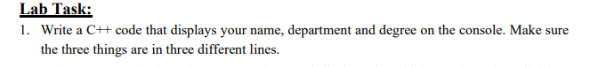

**

**RESULT:**

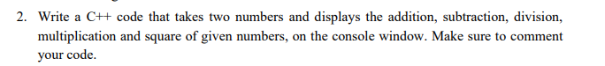

**CODE:**

**RESULT:**

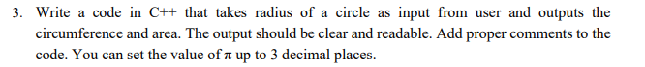

**CODE**:

**RESULT:**



**CODE:**

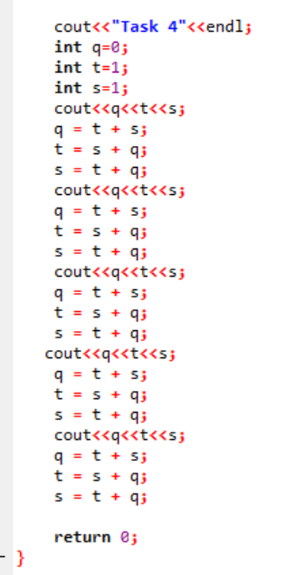

**RESULT:**

**CODE:**

**RESULT:**



**CODE:**

**RESULT:**



**CODE:**

**RESULT:**

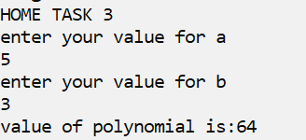



**CODE:**

**RESULT:**

